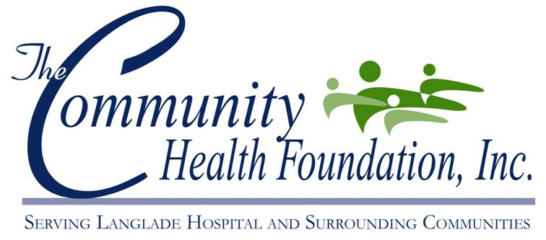
Fund Summaries

Below is a summary of the funds established within the Foundation. Please take some familiarize yourself with them.

Unrestricted Fund – Funds available to be used for various programs without restriction. Monitored and managed by Board of Directors.

Endowment Fund - The Foundation is working toward a million dollar endowment to secure the availability of quality healthcare for generations to come. None of this money can be spent until the endowment reaches $500,000 (which it has). At that time the interest can be utilized to support programs designated by the Board of Directors of The Community Health Foundation.

Oncology Fund – Funds available to meet the needs of cancer patients and their families that live in our community. Gifts to the Beautiful You program are held in this fund.

ACLS Fund (Advanced Cardiac Life Support) – The Community Health Foundation defers some of the cost for advanced training. It also helps to pay for the instructors of the courses.

CME Fund (Continuing Medical Education) – The Community Health Foundation defers some of the cost for continuing medical education and assists in paying instructors of the courses.

Lifeline Fund - Funds available to be used for equipment or services associated with the Lifeline Program. The Lifeline Program is a personal emergency response system primarily used by elderly or people with disabilities. Lifeline provides an immediate link to medical attention through the ER at ALH. We currently provide this valuable service to hundreds of subscribers in 7 counties.

SCU – Funds available to be used specifically for equipment or services associated with the Intensive Care Unit at Aspirus Langlade Hospital.

Hospice Fund – Funds available for LeRoyer Hospice to care for the terminally ill.

Hospital Equipment – Funds available to be used for capital equipment at Aspirus Langlade Hospital. Funds are monitored and managed by the Board of Directors of The Community Health Foundation.

Kidney Dialysis Fund – Funds available to improve quality of care for patients undergoing dialysis treatment and kidney care at the Aspirus Langlade Kidney Care Center.

Rosalia Gardens Memory Care Fund – Funds available for equipment or services for patients in the Memory Care Unit at Rosalia Gardens.

Memorial Walkway Fund – Funds used to maintain the LeRoyer Memorial Walkway on the property of Aspirus Langlade Hospital. Individuals or groups may purchase bricks in honor of, in memory of, or in celebration of loved ones.

Cardio Pulmonary Fund – Funds to be used for equipment or services associated with cardiopulmonary care at Aspirus Langlade Hospital.

ALH H.O.P.E. Fund – Funds used to help ALH employees or their immediate family members during a catastrophic event. Aside from initial seed money, the fund will be sustained through employee giving.

